Notes: Create a Jira ticket for this assignment, work on the tasks listed below, and submit the task completion document by EOD with clear steps and required evidence (outputs/screenshots)

1 . Create user with name Techie and provide sudo access to user.

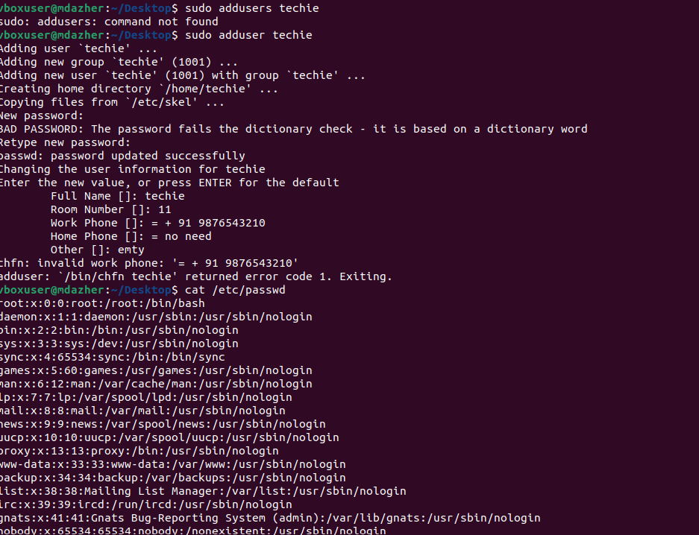
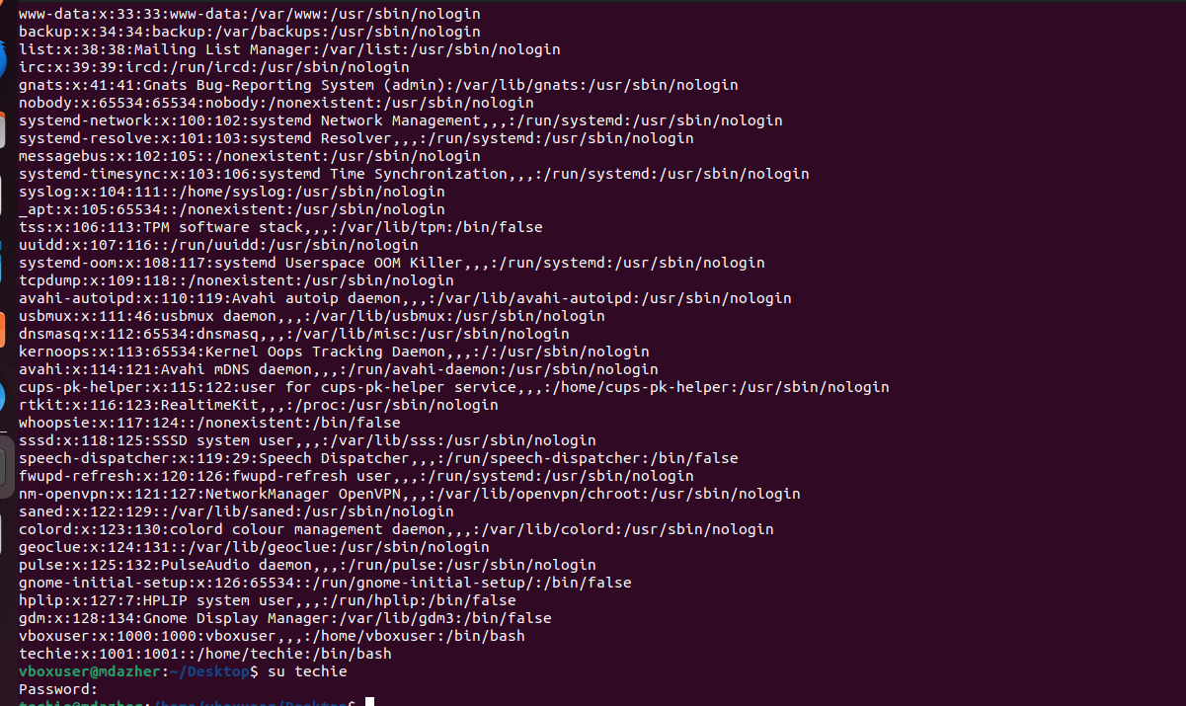
2 . Navigate to the home directory.
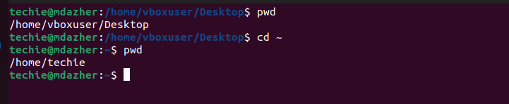
3 . Create a new directory.
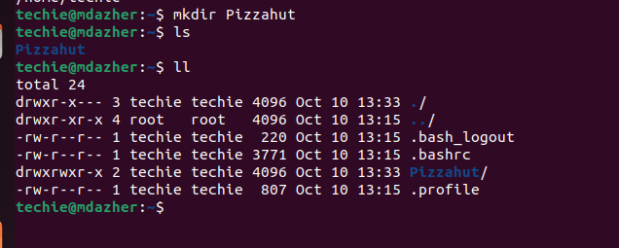

4 . List the contents of a directory.
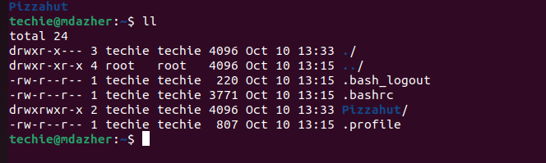
5 . Change the current directory.
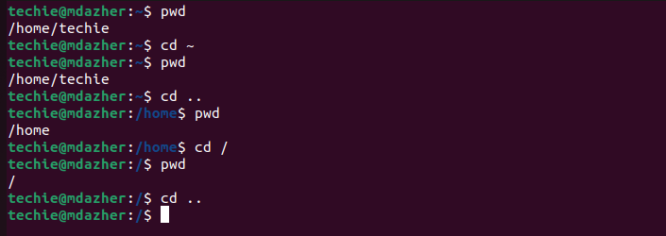
6 . Create a new empty file.
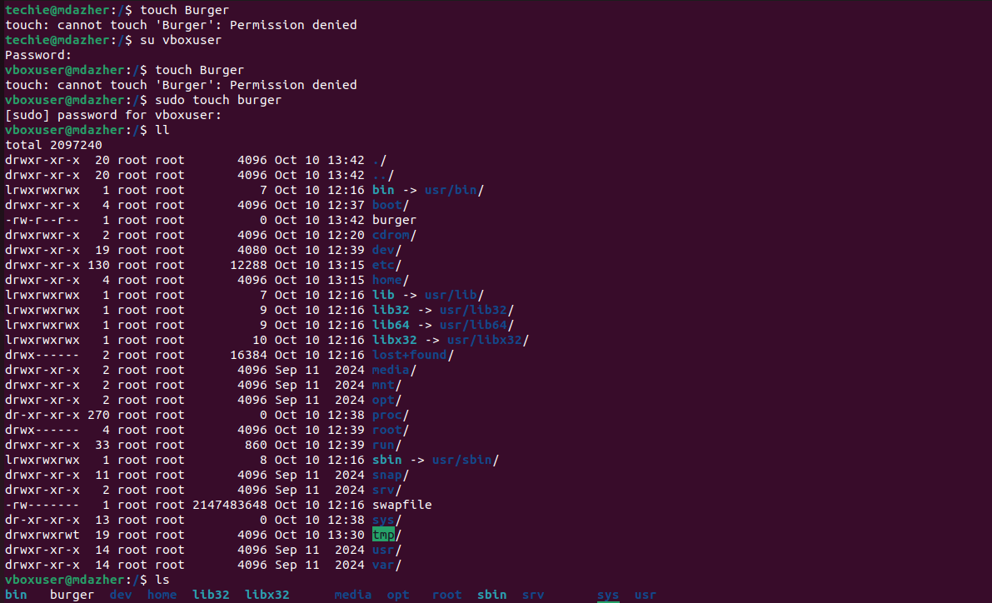

7 . View the contents of a file.

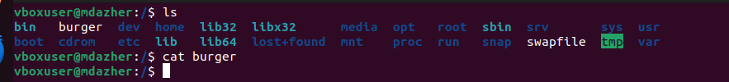

Since burger is currently empty, the command will produce no visible output.

8 . Copy a file to another location.
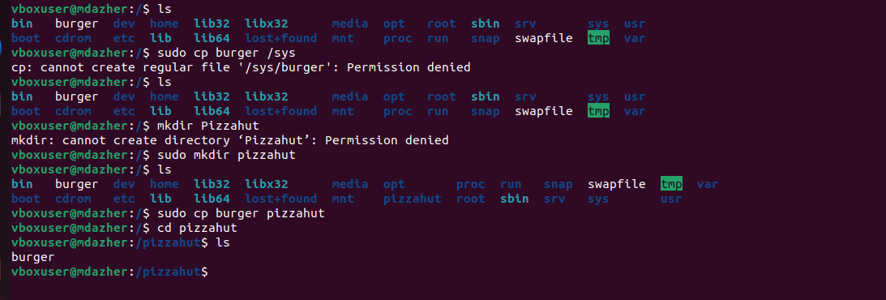

9 . Move a file to another location.
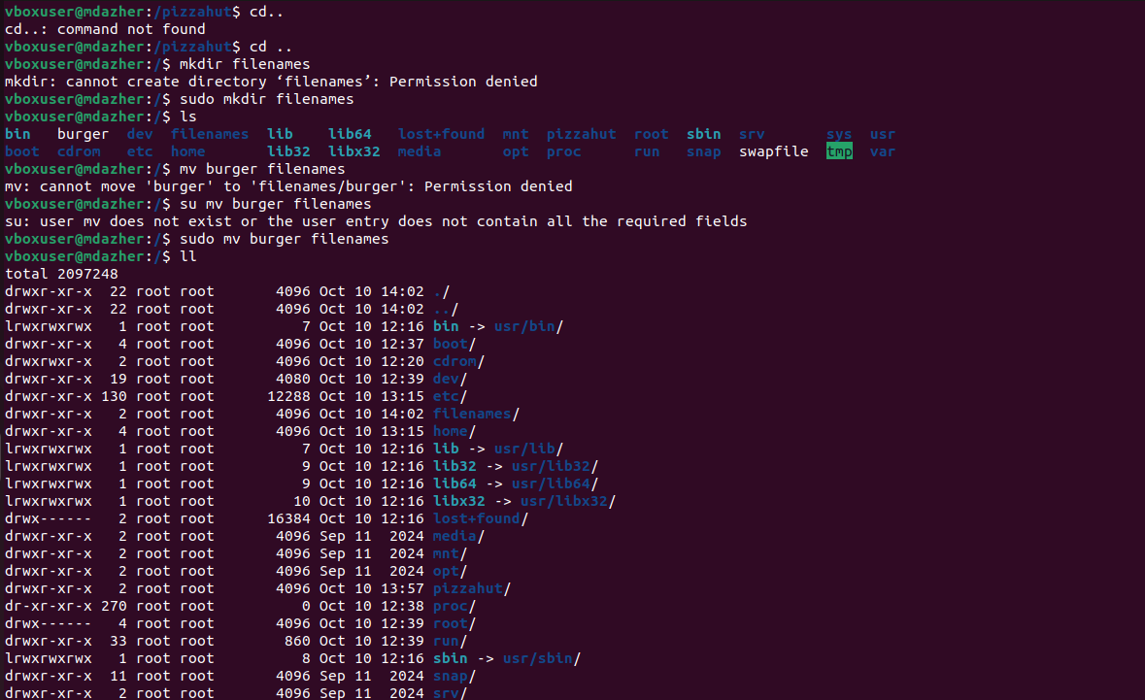

10 . Rename a file.

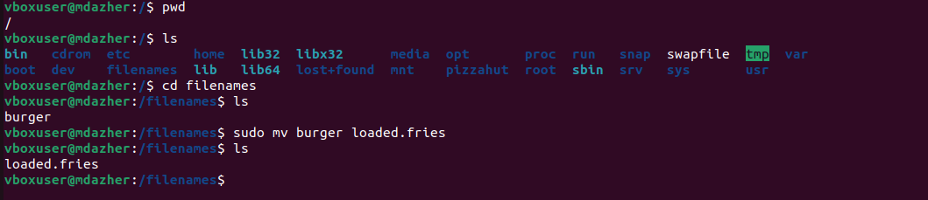

11 . Delete a file.
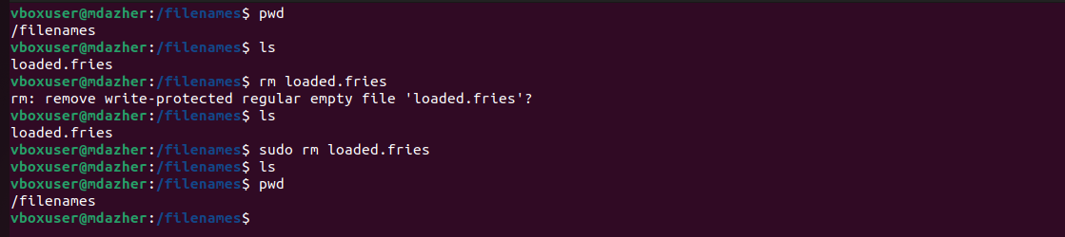

12 . Grant or revoke permissions on a file or directory.

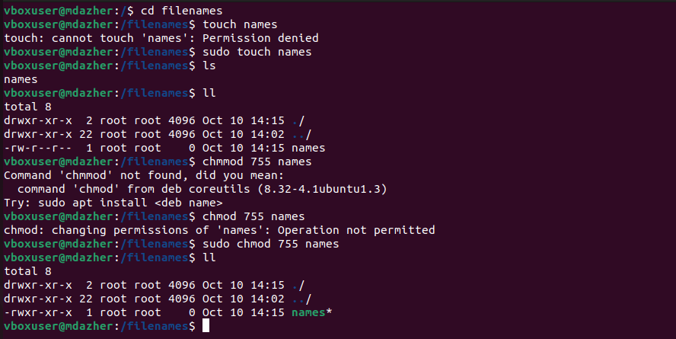

13 . View the current date and time.

14 . Check the system uptime.

15 . View the running processes.

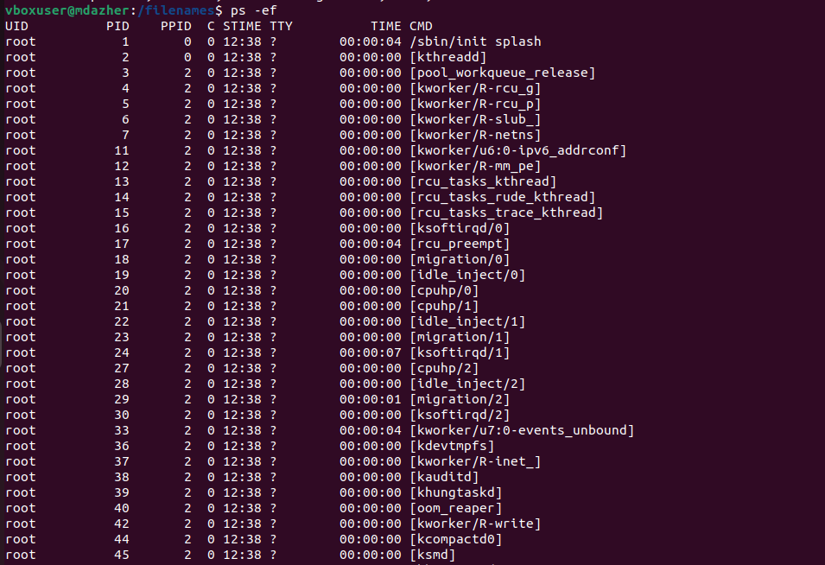

16 . Kill a running process.

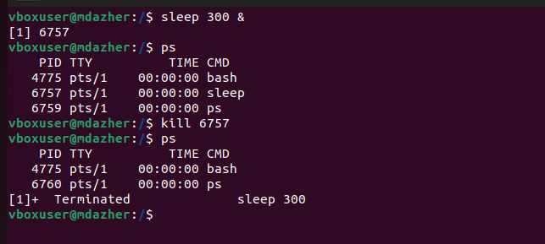

17 . Install a package using the package manager (e.g., apt or yum).
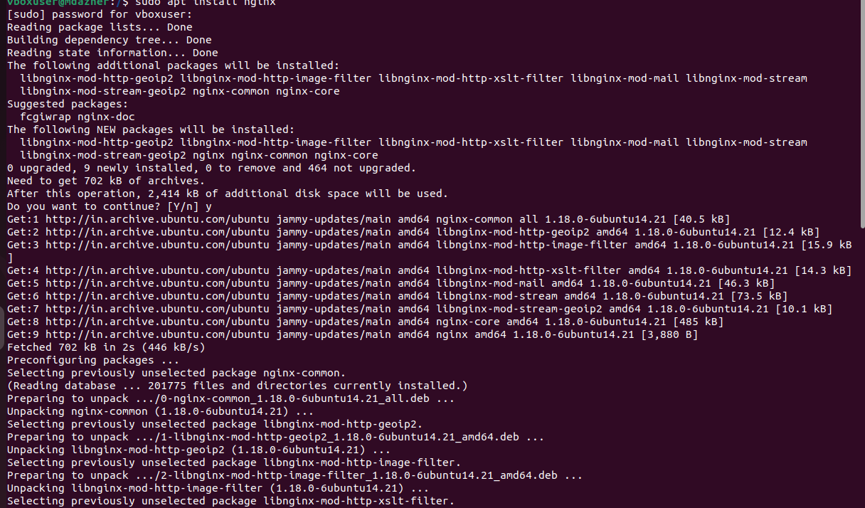
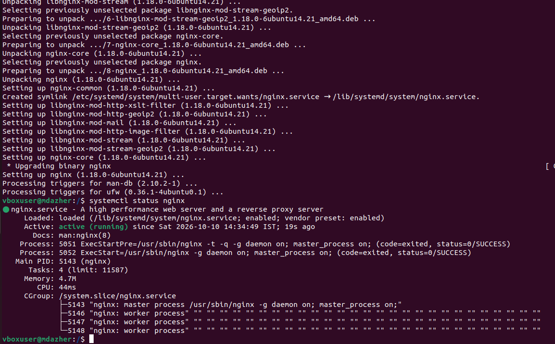
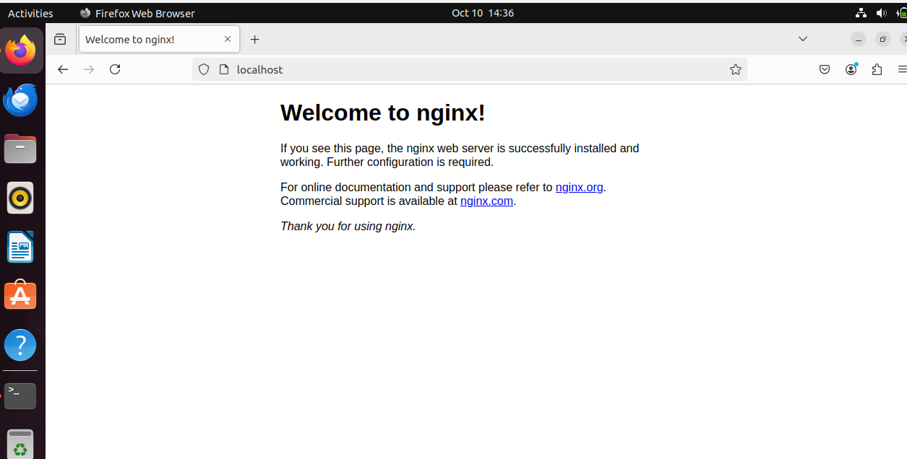

18 . Update the system packages.

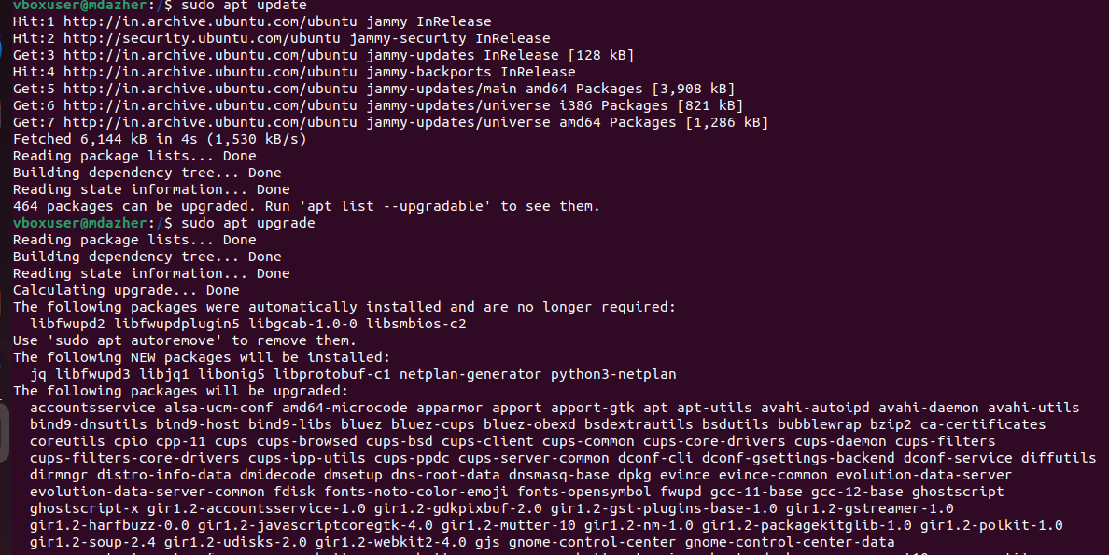

19 . Create a symbolic link.

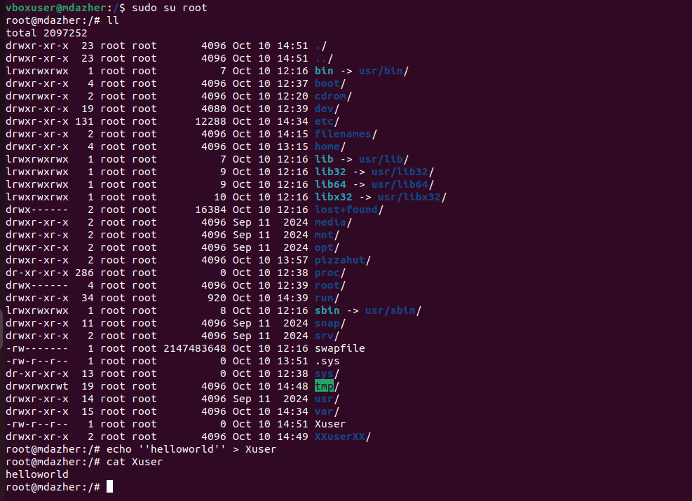

20 . Search for files using the find command.

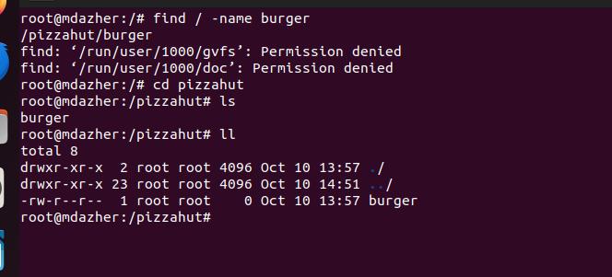

21 . Compress and decompress files using tar.

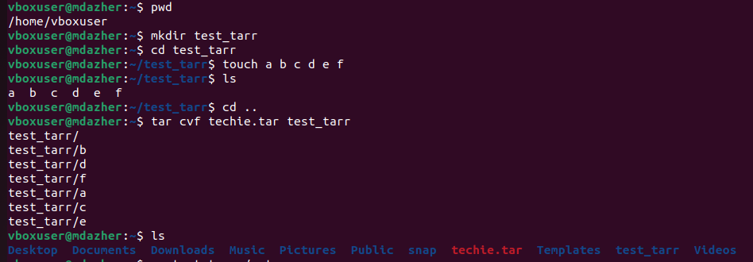

22 . Monitor system resources with top or htop.

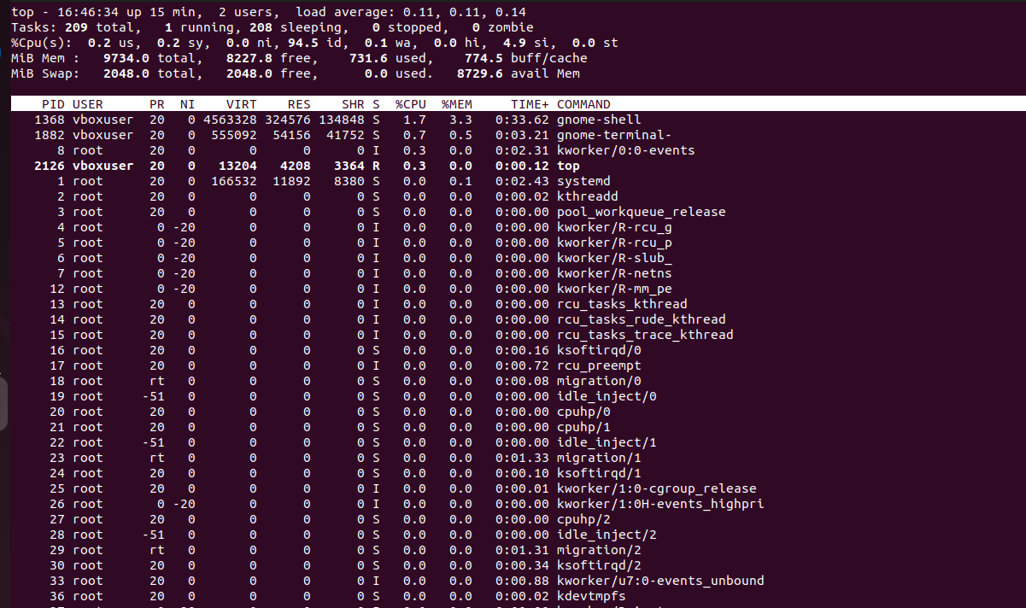

23 . Create and manage user groups.



24 . Set up SSH password less authentication.

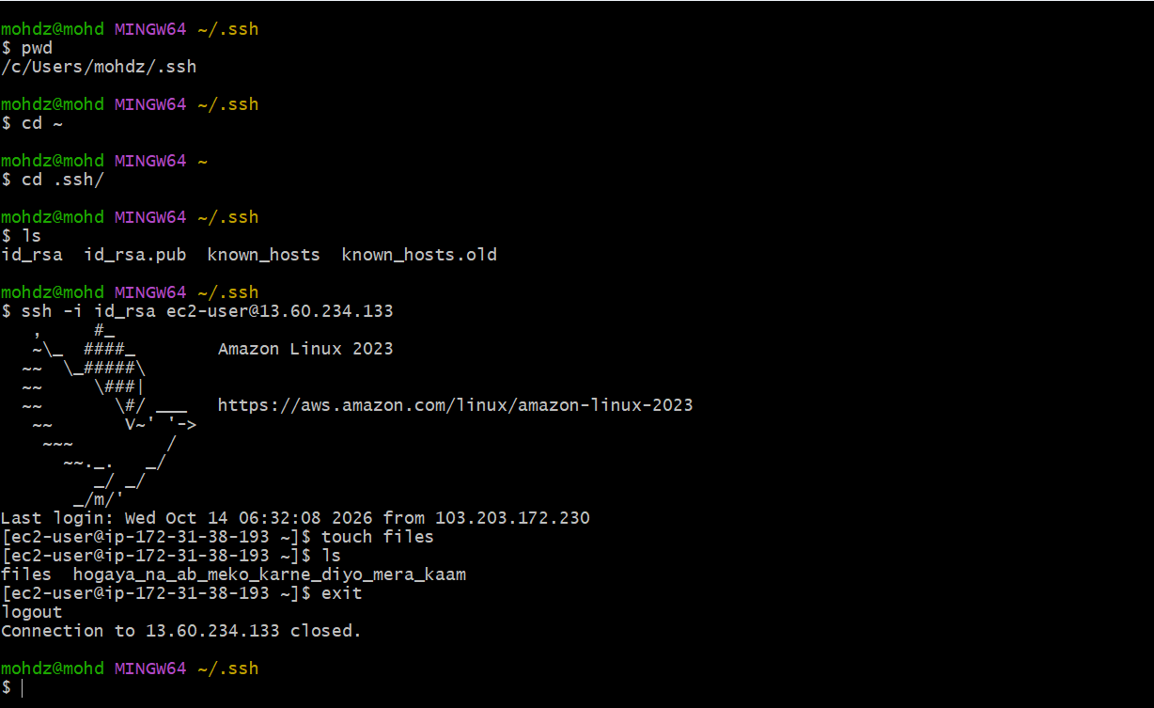

25 . Monitor log files using tail or grep.

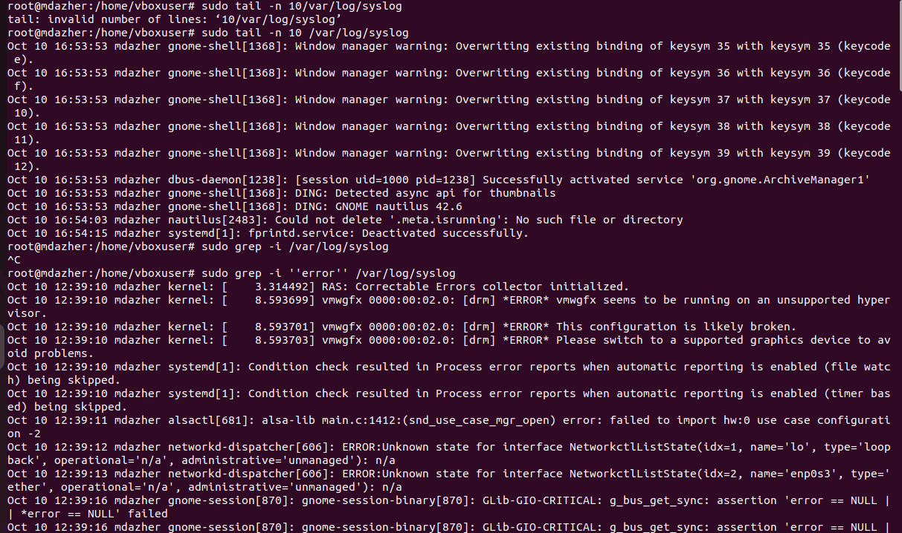

26 . Set up a web server (e.g., Apache or Nginx).
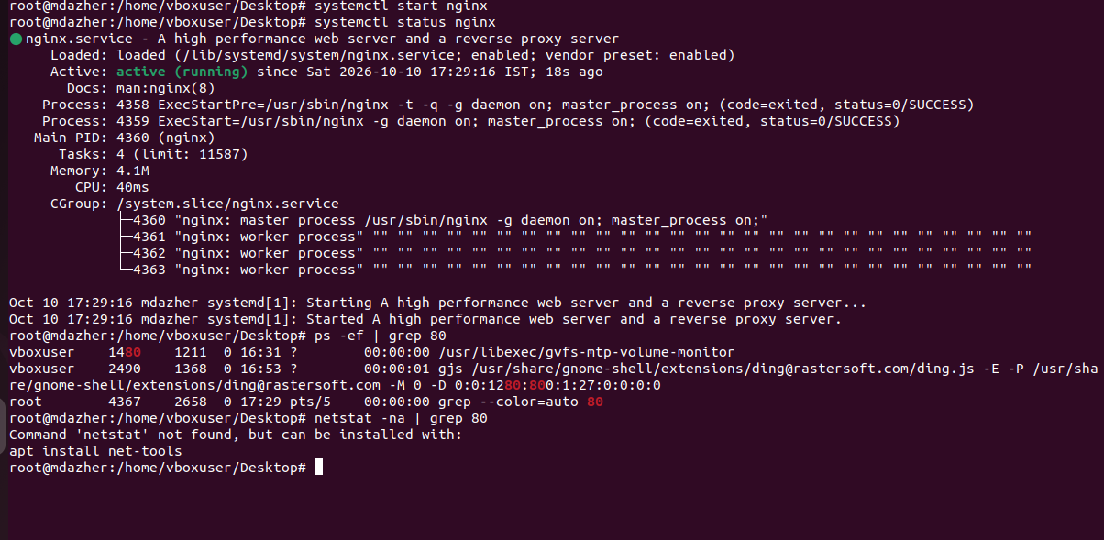
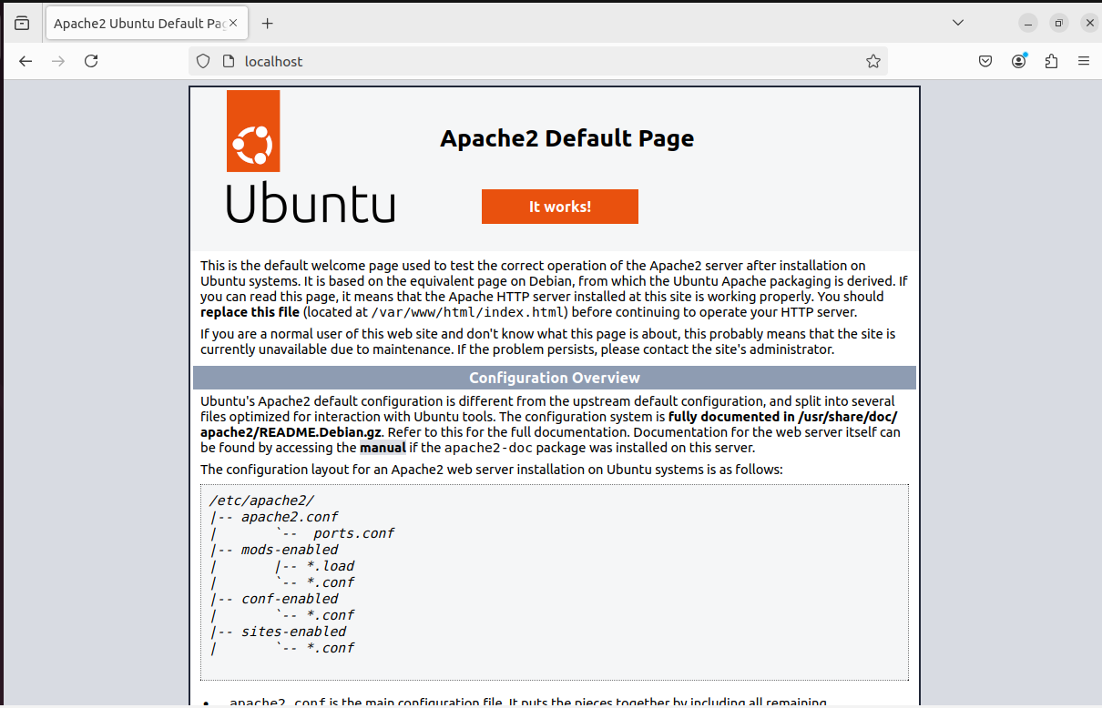

28 . Configure and secure a MySQL Database.

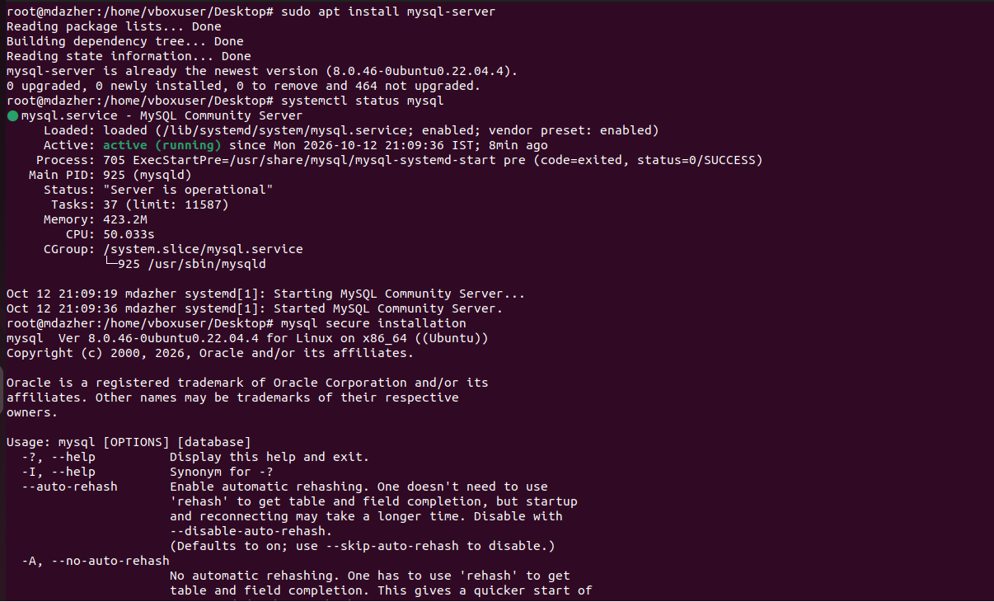
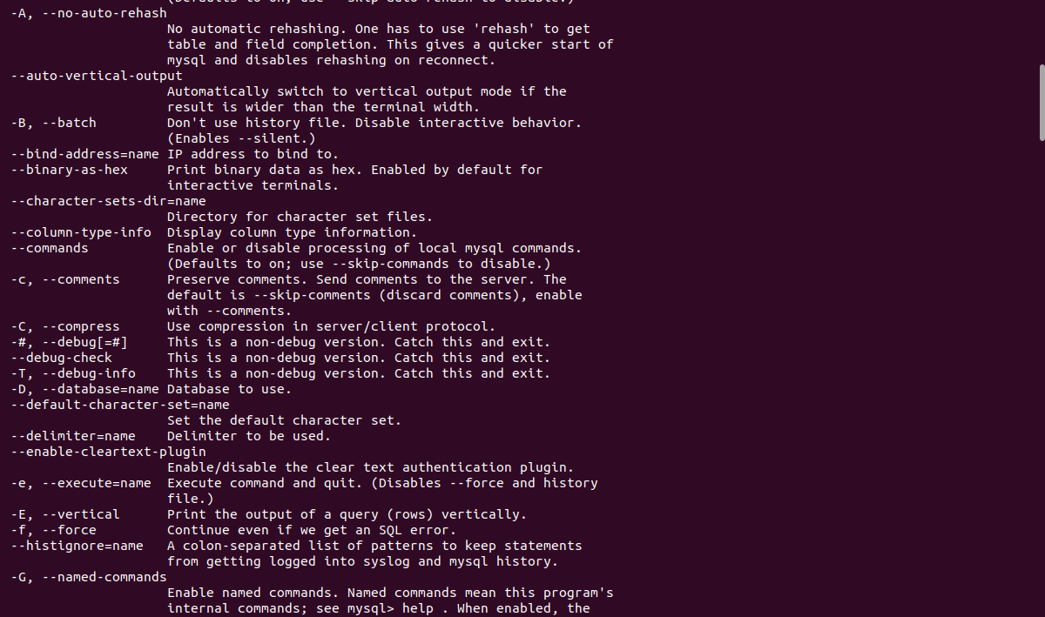
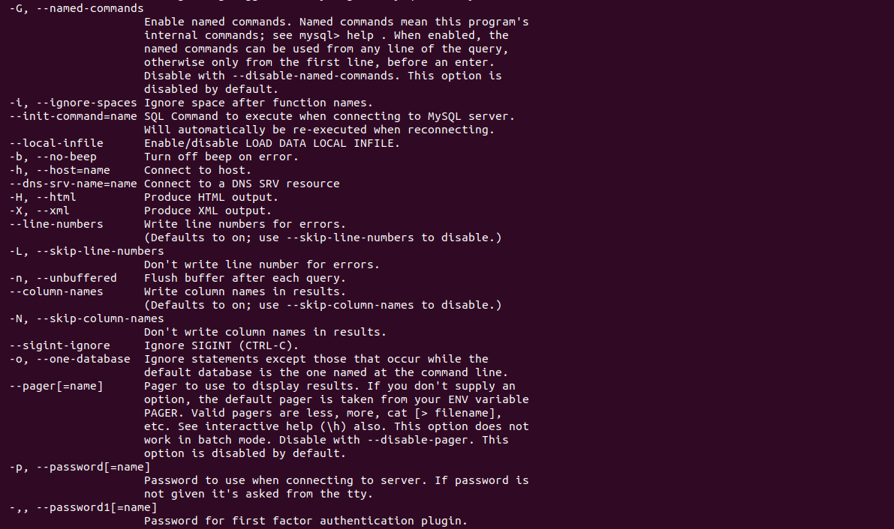

29 . create a service file for Apache Tomcat.(Should execute by using systemtctl command)

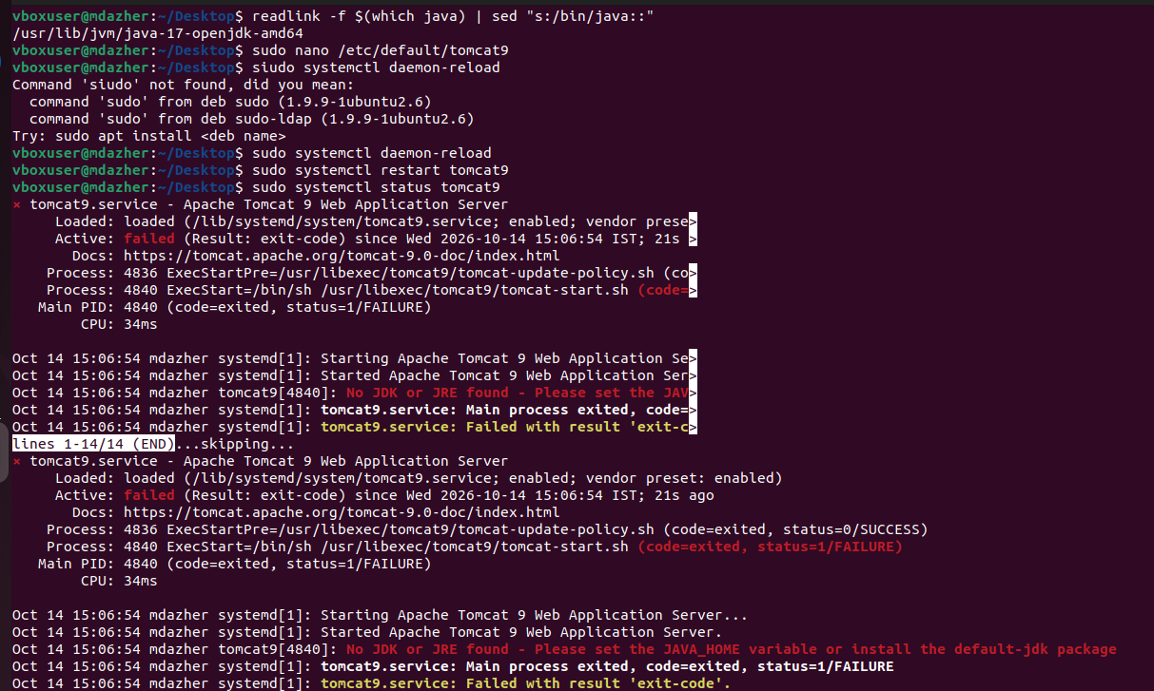
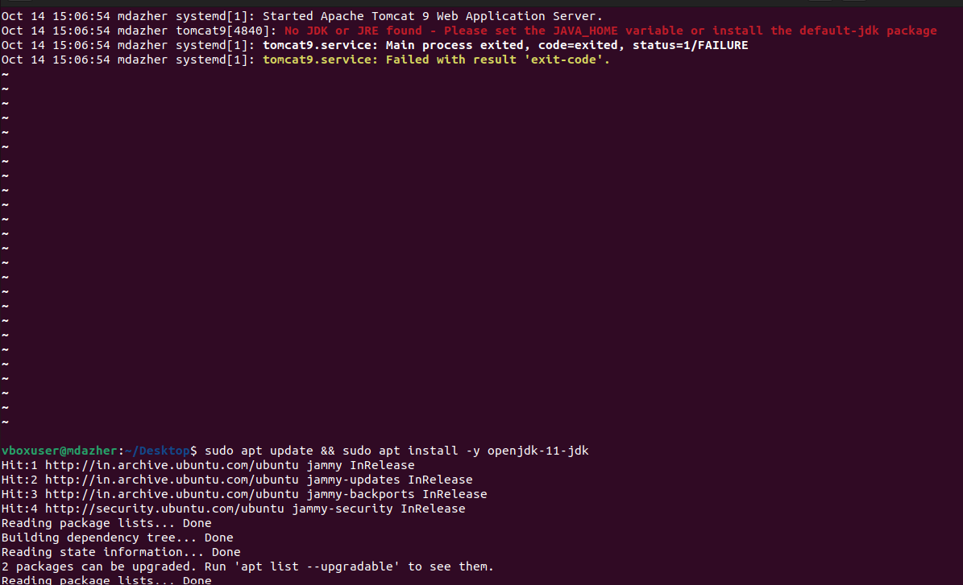
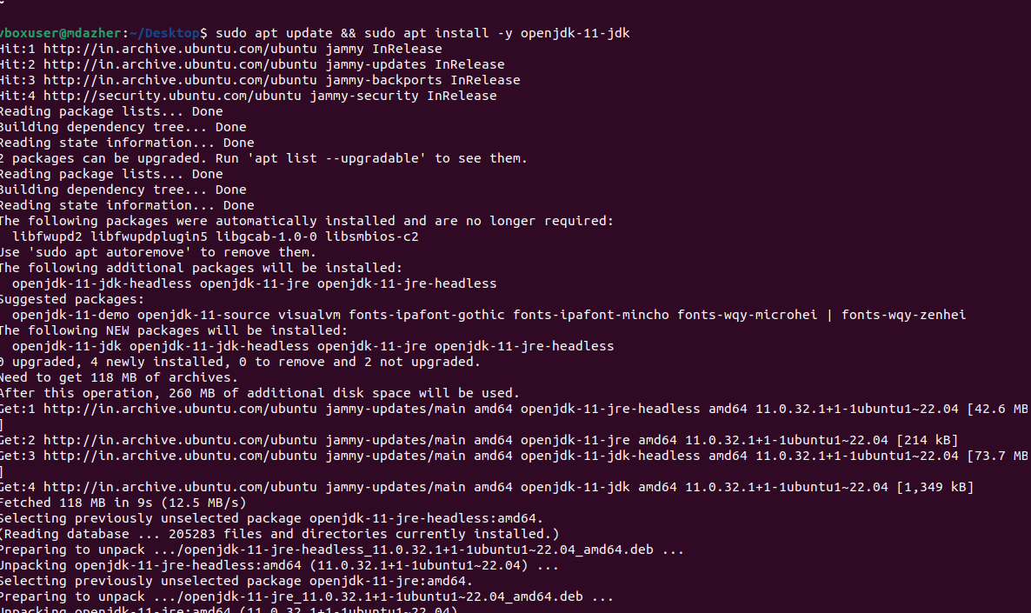
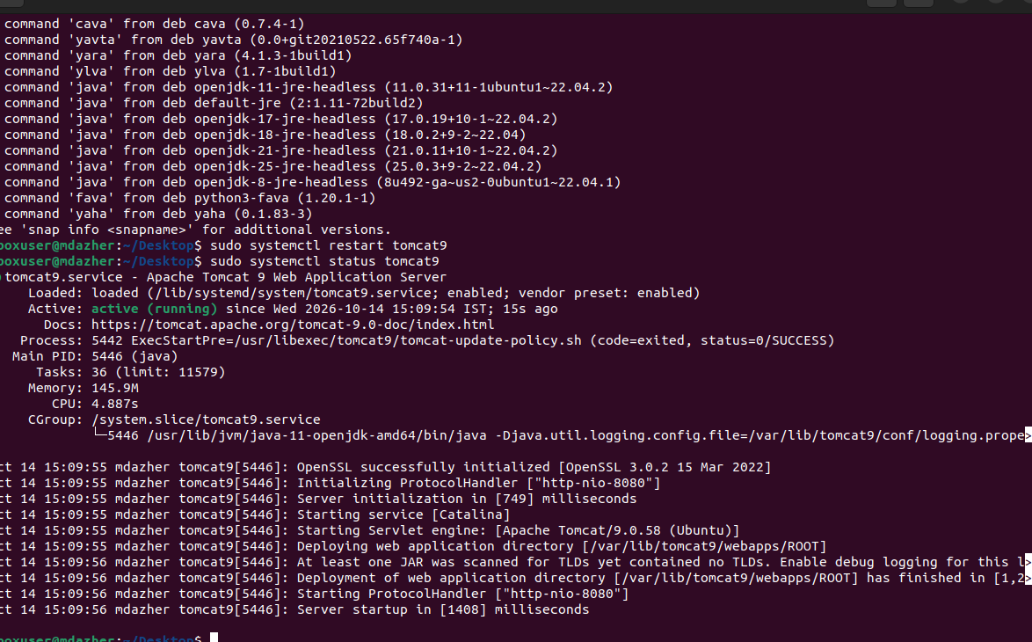

30 . Print specific columns from a delimited file.

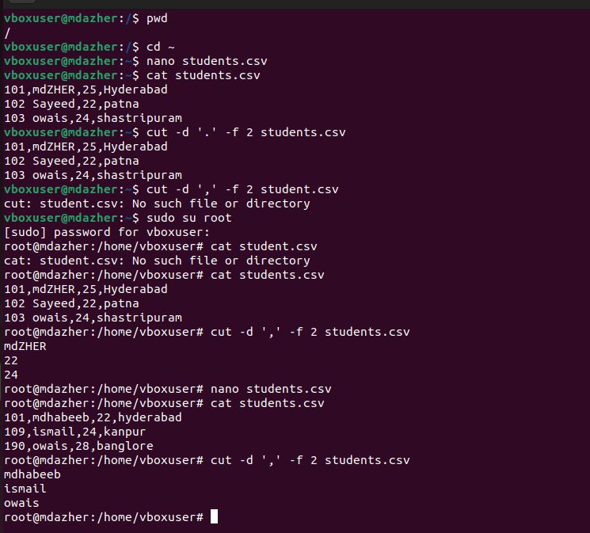

31 . Filter and print lines based on a specific pattern or condition.

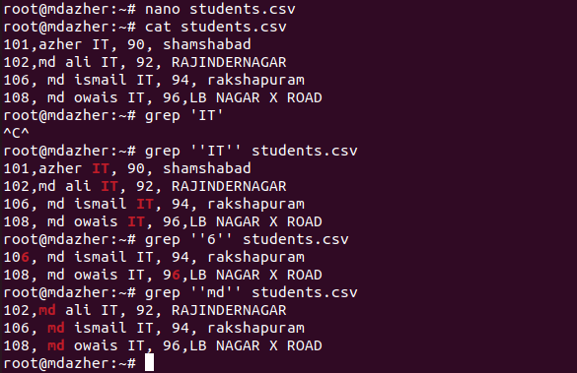

32 . Calculate and print the average, sum, or other statistics of a column.
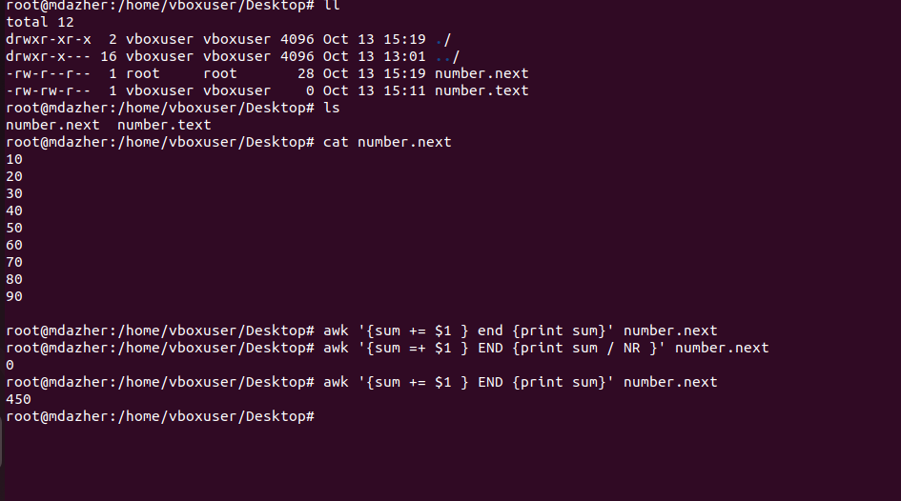

33 . Perform string manipulation, such as extracting substrings or changing case.
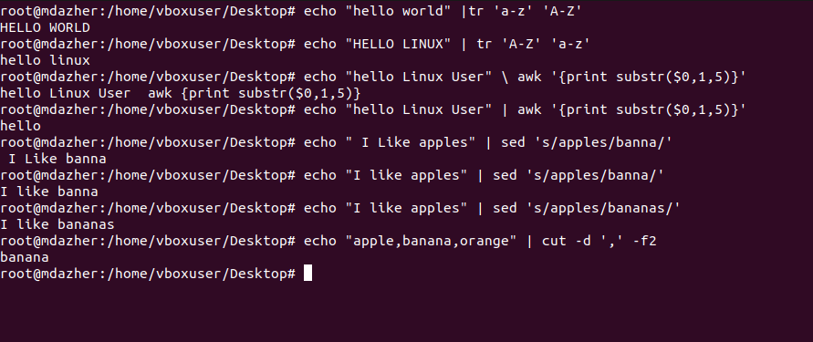

34 . Count the occurrences of a specific pattern in a file.

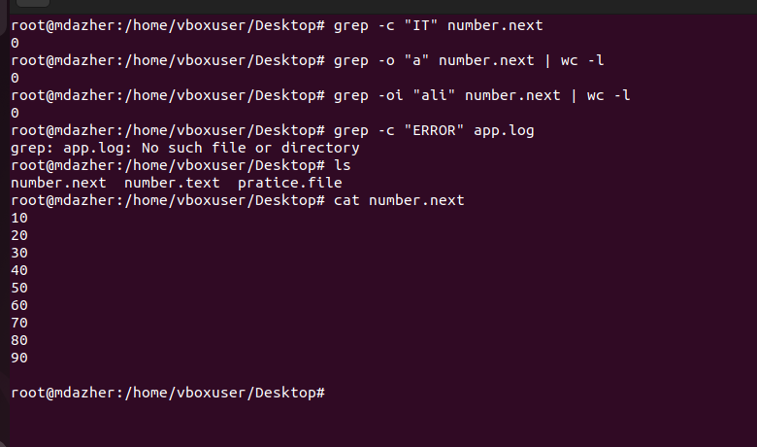

35 . Sort lines based on a specific field or column.
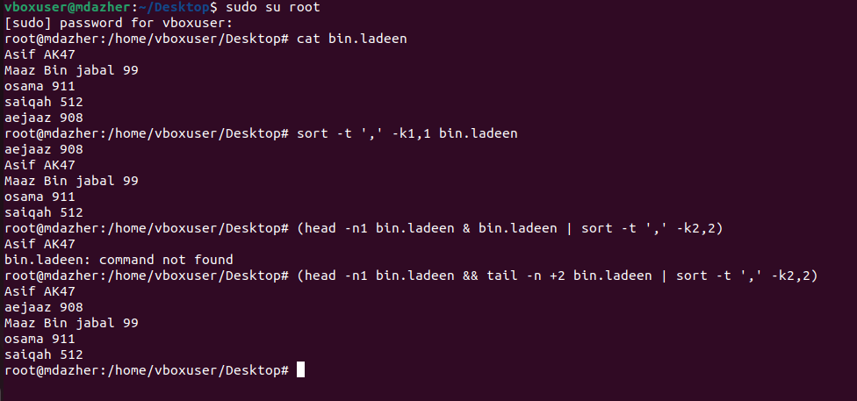
36 . Merge multiple files based on a common field or column.

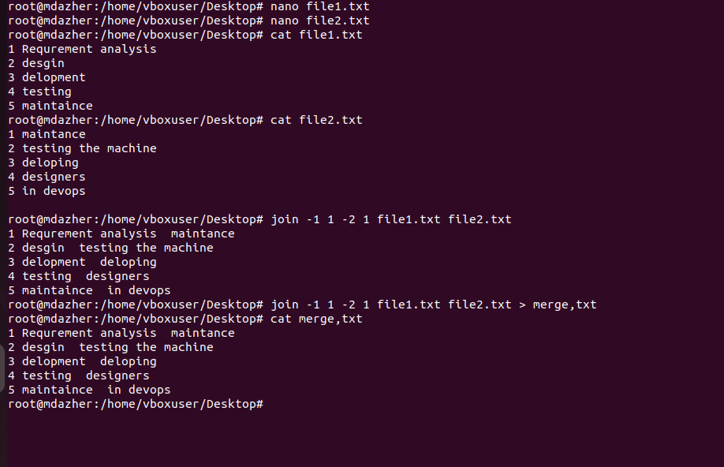
37 . Substitute text in a file using search and replace.
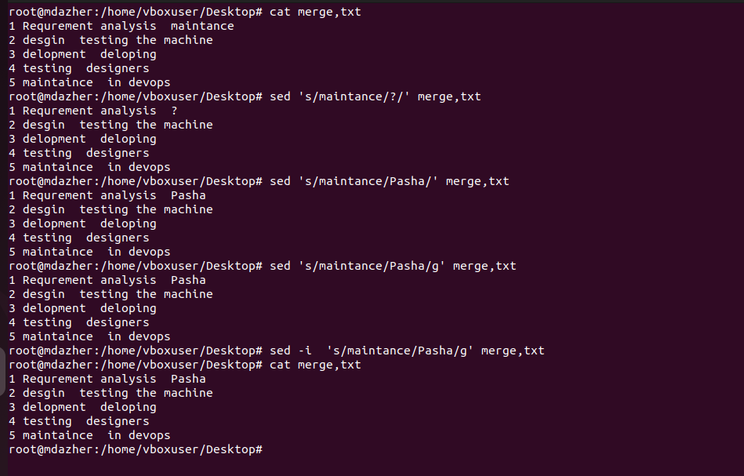

38 Delete specific lines based on a pattern or line number.
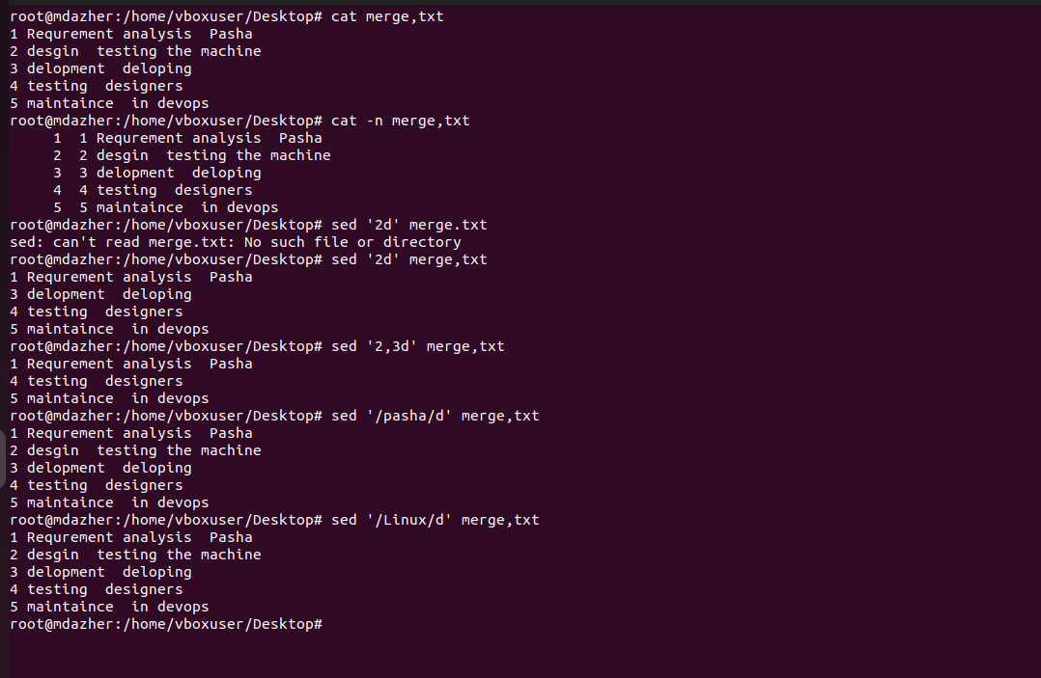
39 . Append or insert text before or after a specific pattern or line.
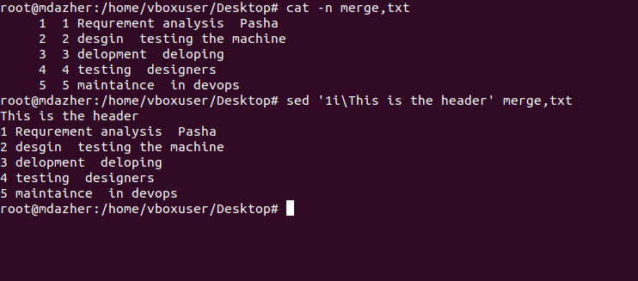
40 . Print only specific lines from a file.
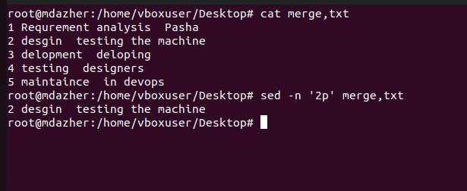

41 . Copy file from linux to windows machine
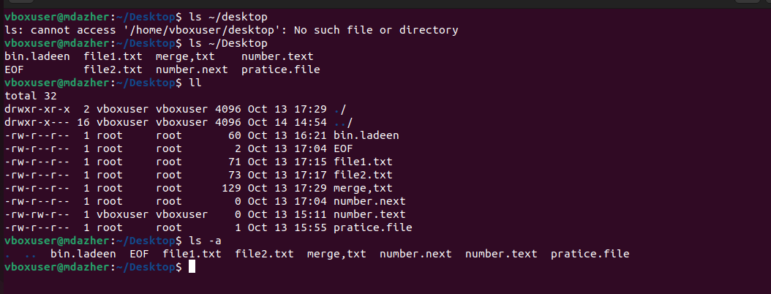
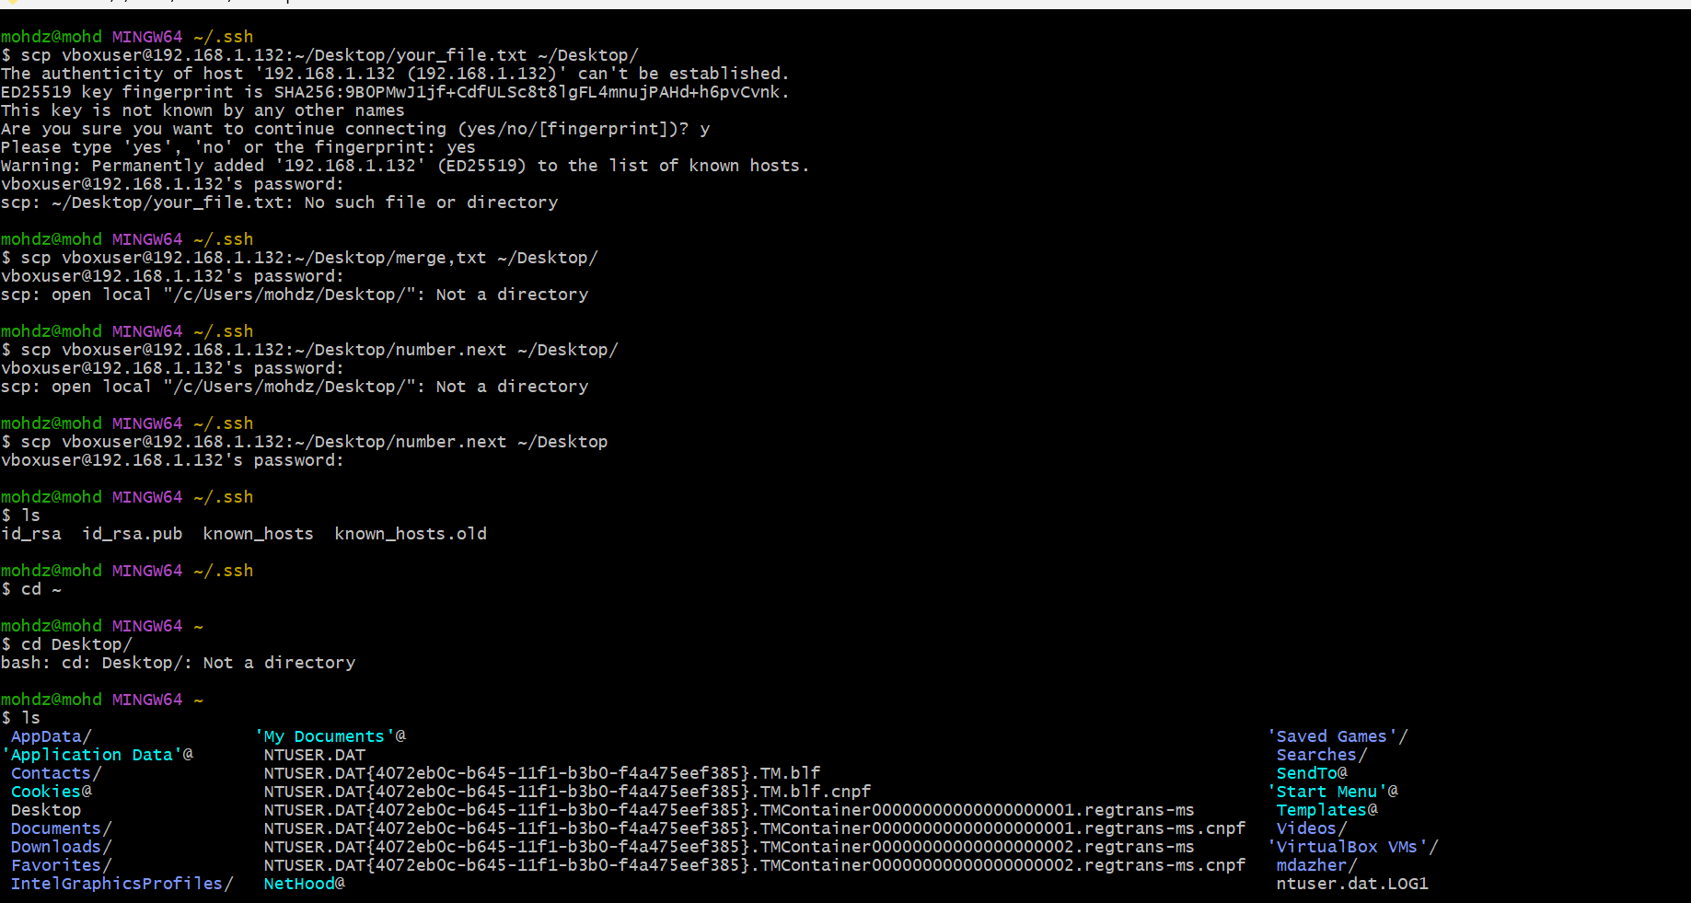
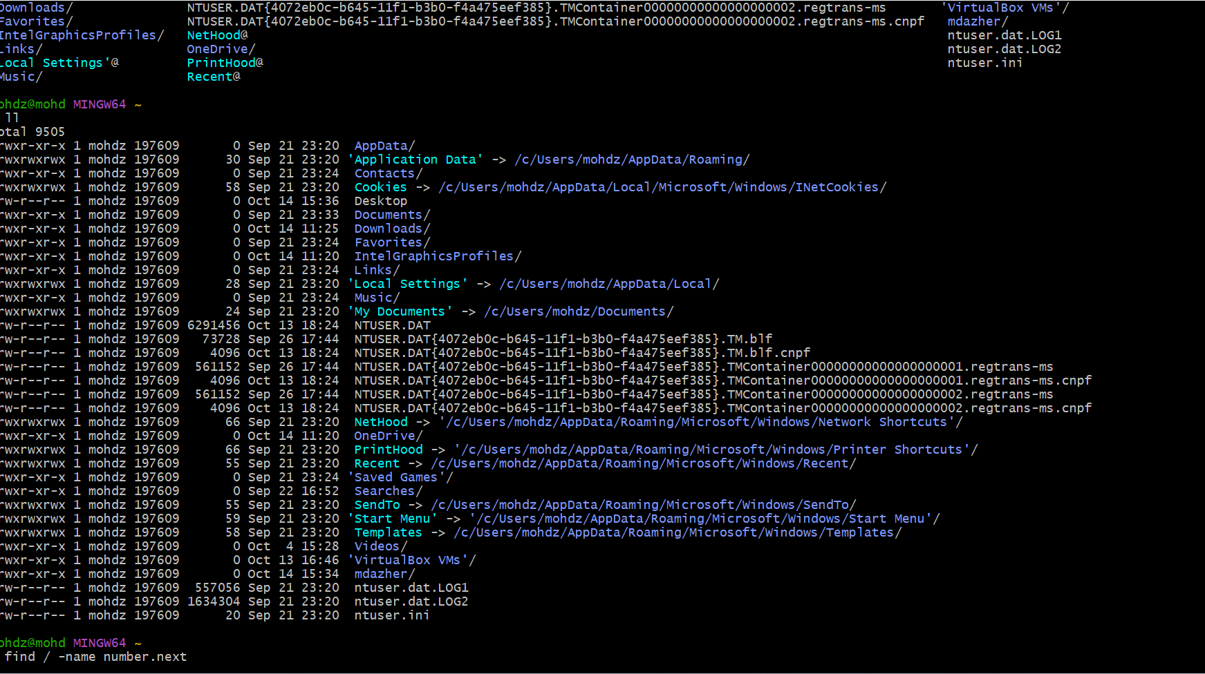
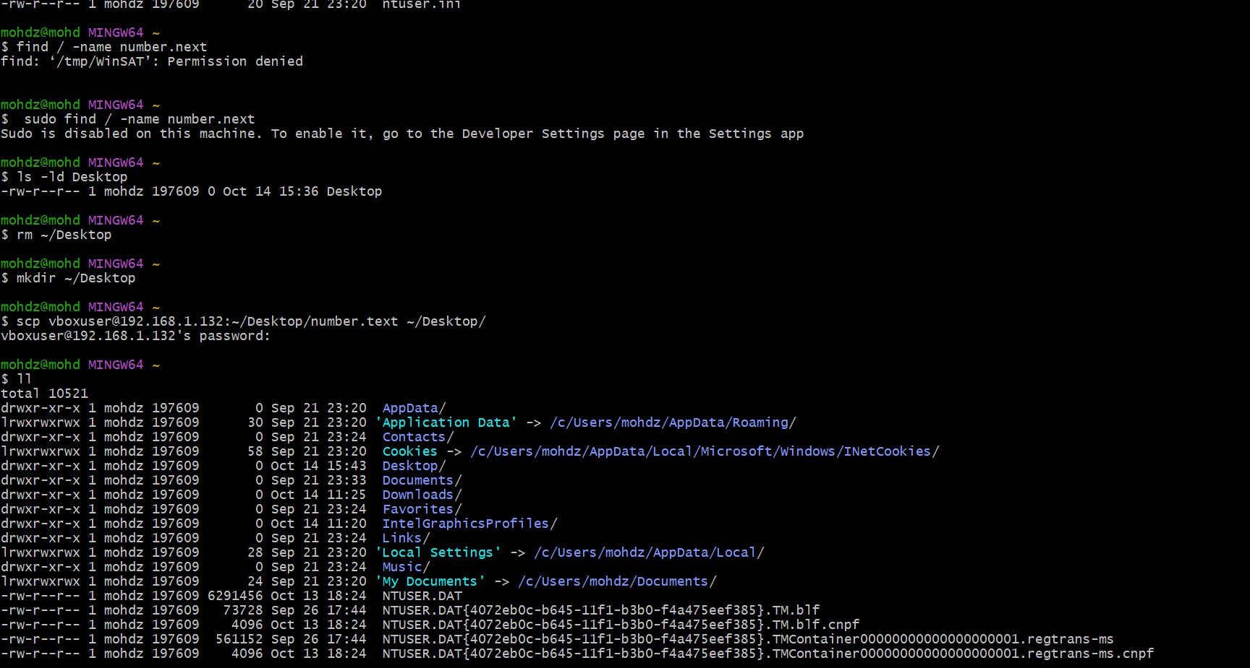
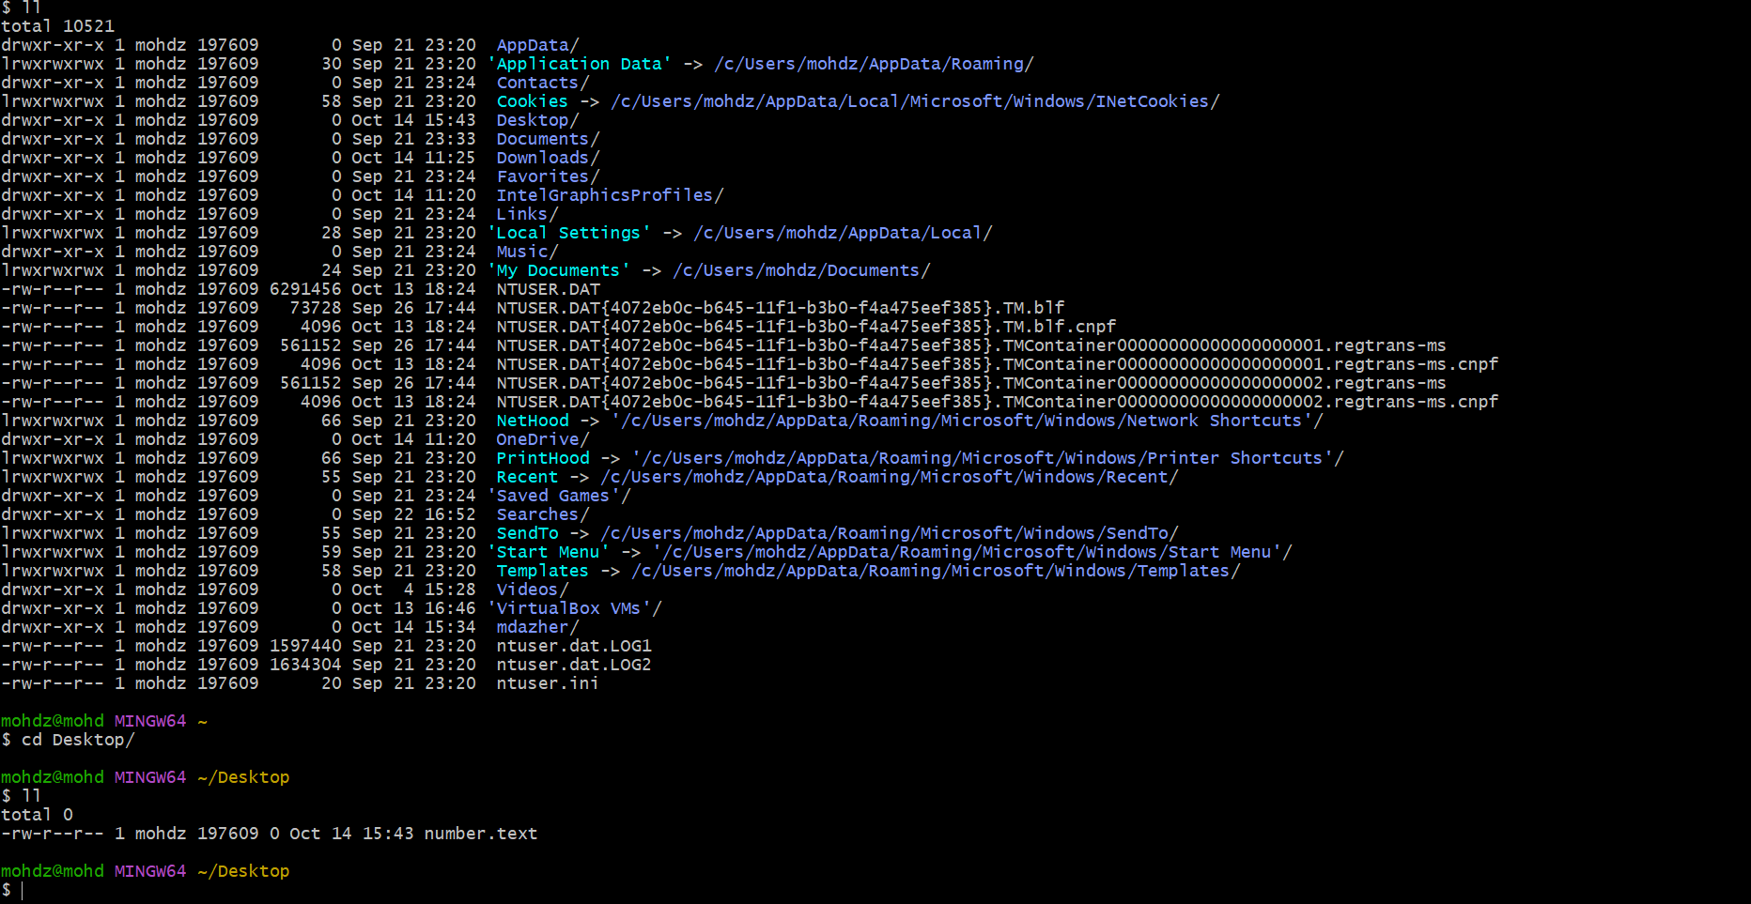
42 . 5 use cases for AWK and 5 use cases for sed
